BSC ARENA
Waynesboro Ga. 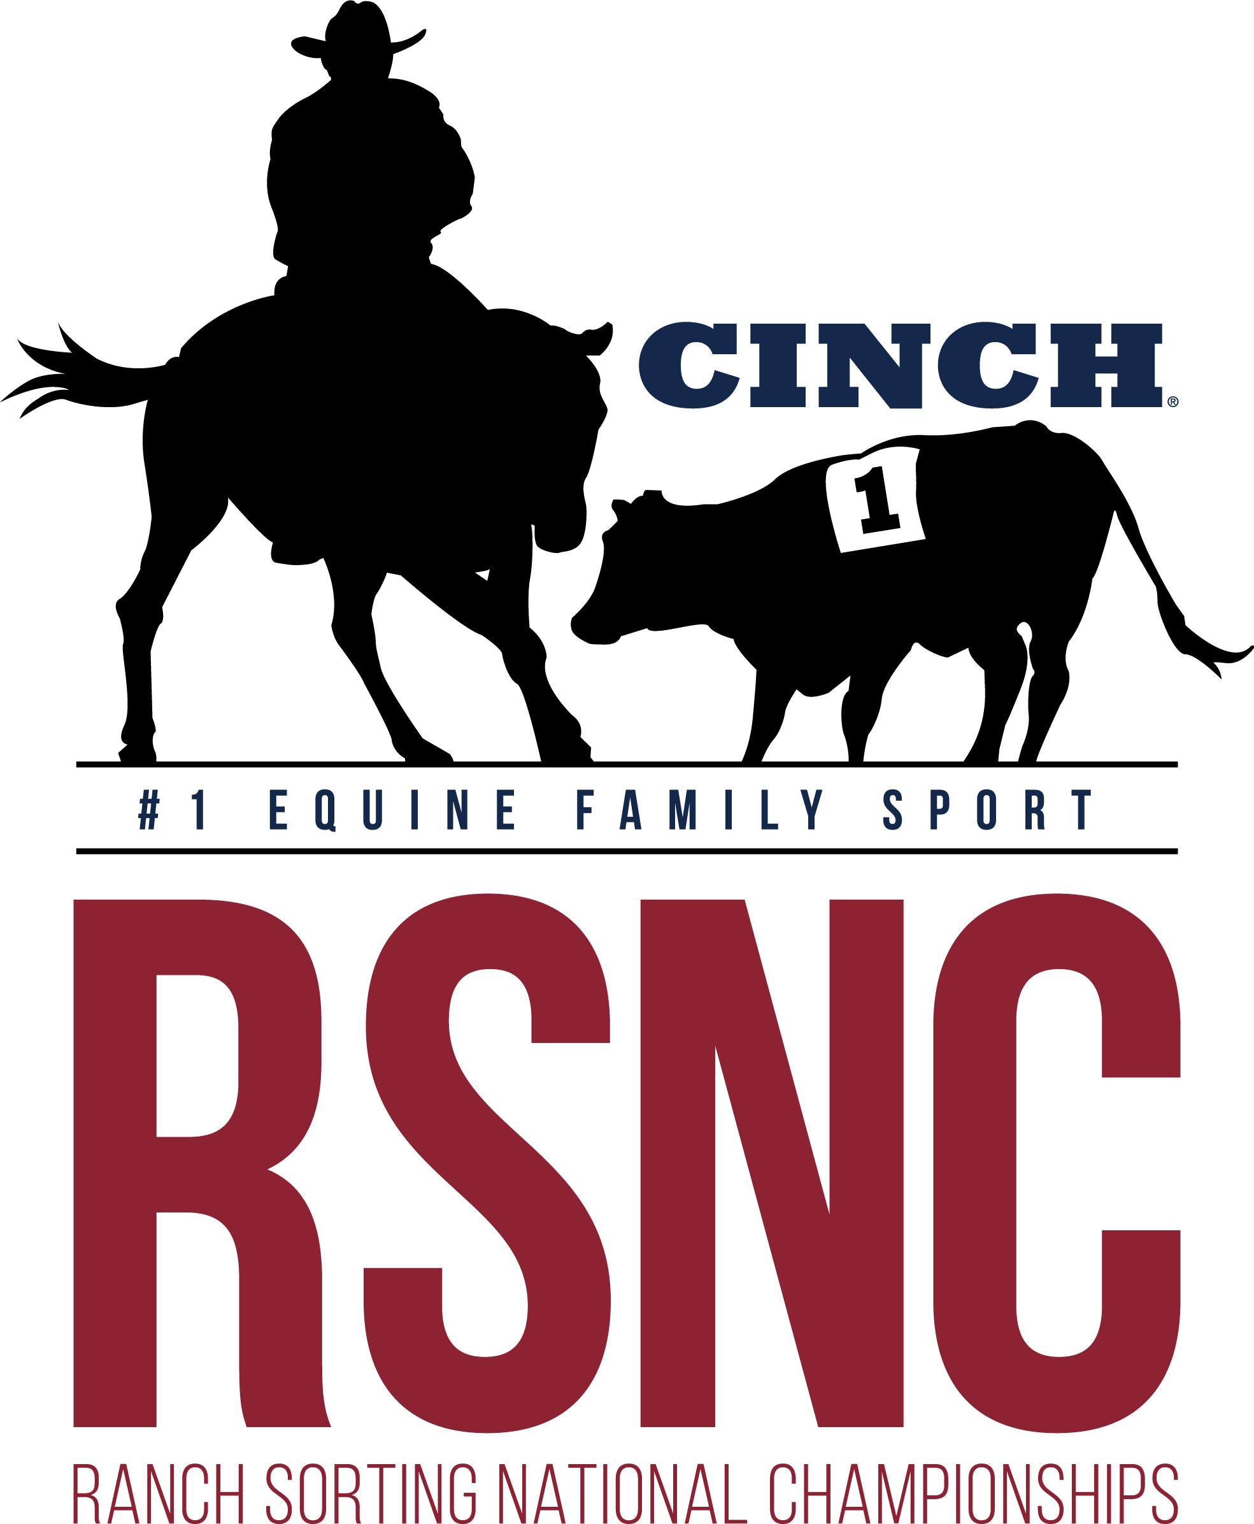

Ranch Sorting

1 SHOW 2 DAYS !!!
STATE
FINALS

Friday January 10th
Saturday January 11th

Year End
Awards

Friday January 10th
*Books open @ 4:30pm - Sort @ 5:30pm*
#8 HC - $34 EF
Masters #10 HC - $34 EF
#12 HC - $34 EF

Saturday January 11th
*Books open @ 8am - Sort @ 9am*

Beginner RH #10 HC - $32 EF (#1 cap on sorter)
All Levels HC - $52 EF 60% payback (capped at highest entry combo) #2 floor
Rookie #11 HC - $34 EF (#2 cap on Sorter)
#7 HC - $34 EF
#10 HC - $34 EF
All Classes 50% payback except All Levels 60% payback
*Entry Fees include a $3/entry RSNC sanctioning fee and $4/entry cattle fee ~ 5 Ride Limit ~
Mandatory Draw- Pick 1 Automatically Draw 1 (Pick up to 4 or Draw All 5)
All Classes with entry fees less than $35 may run one round and top ten unless over 60 teams

Location:  BSC Covered Arena  3976 Hwy 24 South  Waynesboro, Ga | Call to Reserve Stalls $20nt/$30wknd and RV $20nt  706-551-2190  **All info on flyer subject to change**  New RSNC Memberships changes apply
Contact Johnny Lovett at #706-551-2190 or Cliff Chancey at #706-840-3971 with any questions – Entry Fees Payable With Cash, Good Check or Venmo


